**PROBLEM – 3** List all columns of the resource table with a rate between $10 and $20. Sort the result by rate.

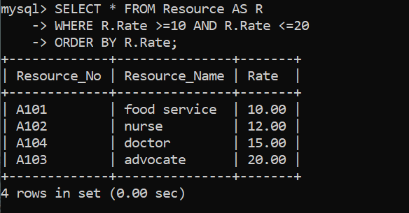

SELECT * FROM Resource AS R

-> WHERE R.Rate >=10 AND R.Rate <=20

-> ORDER BY R.Rate;